Just For Beginners - Jazz Improvisation for Beginners: Part Three
In this lesson we're going to talk about the Blues form. You are probably already familiar with the blues form, even if you don't know it. Jazz, rock, country and rhythm and blues all use some variations of the Blues form.
Before you read more about the blues, download this MIDI file ( if Available) of the C blues. Does it sound familiar? If not, that's OK, you will soon know it well.
There are many variations of the Blues, but the form used most often in jazz is a 12 bar form. Let's look at a 12 bar blues in the key of C.
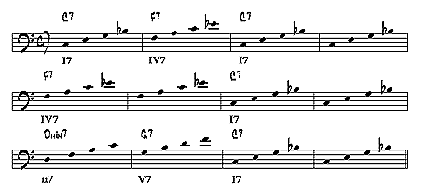
Notice first that, instead of only major 7 chords, we have two different chord types. The "7" after the note name means that the chord contains the 1st, 3rd, 5th and lowered 7th, degrees of the major scale. For example, our C7 chord contains a C, E, G, and B flat. This chord is called a dominant chord.
The other new chord is the minor 7 chord. This chord contains the 1st, lowered 3rd, 5th, and lowered 7th of the major scale. A better way to think of it is the 1st, 3rd, 5th, and 7th, of a natural minor scale, if you know your minor scales.
Lastly, notice the roman numerals underneath the measures. Those numerals are used to show the key and how each chord relates to the tonic chord. In our case the key is C, so the C7 chord is labelled I7. Since F is the 4th note of the C major scale the F7 chord is labelled as IV7. The G7 chord is labeled V7 because G is the 5th note of the C major scale. All of those chords use capital roman numerals because they have major thirds. The Gmin7 chord is labeled ii7 (lower case for II7) because that chord has a minor third.

It's time to learn a new scale. This one is called the blues scale. Below, the Blues scale is given in the key of F.
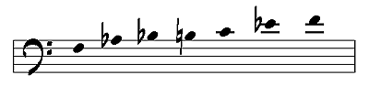
Notice that the scale contains the 1st, lowered 3rd, 4th, raised 4th, 5th, and lowered 7th notes of the F major scale. Play it slowly up and down, listening carefully to the sound of the scale. Sound familiar? Chances are that you've heard this scale before.
This scale is very useful for the blues because it will sound good anywhere in the blues form, provided you're in the right key.
It has the F blues scale written out in 8th notes over the whole form, and then the chord symbols for the blues in F. Start the MIDI file and play the blues scale for two choruses (two times through the form) and then improvise using only the notes in the blues scale. I've provided the chord symbols for you so you can get used to seeing them, but don't worry about them yet. Just pick notes in the blues scale and you will sound fine.
Still having trouble? Try simplifying your note choices by practicing these combinations:
- Just the 1st and 2nd notes of the blues scale
- Just the 1st, 2nd, and 6th notes of the blues scale
- Just the 1st, 2nd and 3rd notes of the blues scale
- Just the 2nd, 3rd, and 5th notes of the blues scale
- Just the 1st, 2nd, 3rd, 5th, and 6th notes of the blues scale (minor pentatonic scale)
- Make up your own combinations
Remember while your practicing improvisation to play with a good sound and to play right in tempo with the MIDI file. If you find yourself playing out of time or with poor breath support, stop playing for a few measures and give yourself a chance to rest and think about what you want to play next. It's OK to use space in your soloing, don't feel like you have to play EVERY measure.
- Once you get comfortable with blues in F, transpose the scale to different keys and practice with these MIDI files: C Blues, F Blues, Bb Blues, Eb Blues, Ab Blues, Db Blues, Gb Blues, B Blues, E Blues, A Blues, D Blues, G Blues

